Clarion Housing Association and the Sutton Estate

A Report by Michael Parkes, Member of the Chelsea Society’s Planning Committee for Stanley Ward.

1 History
At the beginning of the 20th century, the 4.5-acre area in Chelsea bounded by Leader Street (now known as Ixworth Place), Cale Street, and College Street (now known as Elystan Street) was home to many overcrowded small houses.
In 1908, the William Sutton Trust, established by philanthropist William Richard Sutton, purchased the area. They demolished the houses and built 14 red-brick residential buildings, designed by architect E.C.P. Monson, for social housing. The buildings, which housed 2,200 people in 764 apartments, were completed in 1913. (see photograph below)
The buildings are currently owned by Clarion Housing Group, a Housing Association formed by the merger of Affinity Sutton, an affordable Housing Trust in London and owner of Sutton Estate, and Circle Housing in 2016. Clarion is now the largest Housing Association in the United Kingdom with 125,000 properties across more than 170 local authorities.
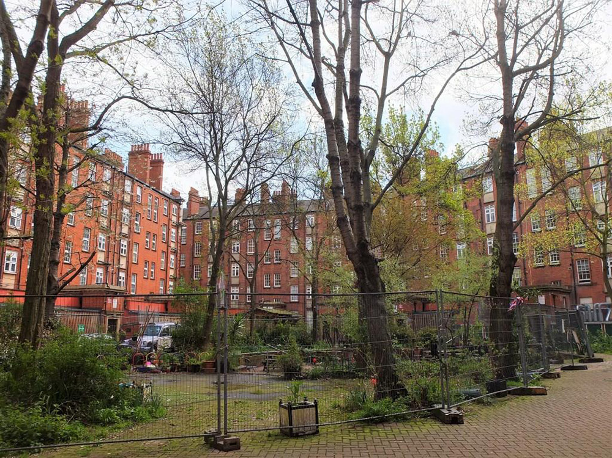
2 Proposed demolition and regeneration : Recent Planning Decisions
On 15 November 2015, Affinity Sutton submitted a planning application for a regeneration and demolition project that would see most of the estate's blocks (buildings A-K, N-O) replaced with new buildings containing a mix of private and social housing, reducing the number of social housing units by nearly a third. Residents accused the trust of "social cleansing", and in 2015 some of the inhabitants of the estate formed Save the Sutton Estate Ltd., a non-profit organisation whose main goal was to stop the demolition of the estate and further their alternative proposal for infill development and rehabilitation of existing units. See Save Sutton Estate evidence to 2017 Inquiry:- https://www.rbkc.gov.uk/idoxWAM/doc/Appeal%20Correspondence-2079752.pdf?extension=.pdf&id=2079752&location=VOLUME2&contentType=application/pdf&pageCount=1
In 2016, Clarion (Affinity) moved residents out of 159 flats and had workmen make the properties uninhabitable to squatters by smashing windows, doors, sinks and toilets in advance of a plan to demolish the buildings and replace them with 237 new social rent flats and 100 to be sold at market rate to support the redevelopment.
In November 2016, Kensington and Chelsea Borough Council rejected planning permission for the estate demolition and redevelopment application submitted by Clarion (Affinity Sutton) on the grounds that the net loss of social housing units was unacceptable, and a public inquiry was held. In August 2017, it was suggested that the empty flats could temporarily house the survivors from the Grenfell Tower fire in North Kensington.
Clarion Housing Group appealed to the Secretary of State for Housing, Communities and Local Government against the decision by Kensington and Chelsea to reject their plan, arguing that they had revised their plans to increase the provision of social housing to avoid a net loss in social housing, and as such their original application (with revisions) should be approved. On 18 December 2018 the Secretary of State issued a decision refusing the appeal and upheld Kensington and Chelsea Council's view that an entirely new application would be required.

3 Refurbishment

Clarion sets out new future for the Sutton Estate Press Statement :14 November 2019 :-
Clarion Housing Group, has today committed to a £37 million investment package to improve the entire Sutton Estate and deliver at least 80 new social rented homes to Kensington and Chelsea.
The plans, which will be developed with residents, will see the 106 year-old homes in blocks A-D (currently empty as they do not meet decency standards for accommodation) undergo a full refurbishment. All of the new homes will be for social rent and priority will be given to residents currently living on the estate.
Residents in the remaining 303 flats on the estate, blocks E-K & N-O, will benefit from new kitchens and bathrooms and other upgrades. Clarion has also committed to improving the outdoor spaces. The new scheme has no homes for private sale.
Clarion will work with residents to further shape the new plans, with a view to work beginning in summer 2020. (see 4 below)
Clare Miller, Chief Executive of Clarion Housing Group said: “The Sutton Estate is an integral part of the community in Kensington and Chelsea and securing the future of social housing on the estate has always been the priority for us. Our new plans will modernise the existing homes and the estate as a whole, benefitting not just today’s residents but future generations. By delivering at least 80 new social rented homes, we are also able to play a key role in helping to address the borough’s acute shortage of genuinely affordable housing.”

4 Clarion Information/Consultation Meeting with residents held on 27th January 2020 4pm at Kingsmill House .
Michael Parkes attended on behalf of the Chelsea Society. The event was essentially an opportunity for Clarion staff, accompanied by Wates (Property upgrade) staff to inform about 60 residents of their refurbishment plans and programme , as well as to make a start on consulting / working with residents on problems / choices etc. Work will start with internal improvements / property upgrade before moving on to external works and improvements to communal areas. The improvements are intended to last for 20–30 years. It is recognised that existing residents in Blocks E-K and N-O as well as in surrounding streets will be seriously impacted by the work, (noise, dust etc) (nb CMP and CTMP) .
Michael Parkes collected all hand outs, requested a copy of the indicative works programme (not available as a hand out) and made some contacts. (Nathalie Down : Clarion Regeneration, and a local resident)
The Wates – Clarion handouts broadly covered the information provided and discussed :-
- Major works : what you need to know eg identification ; health and safety ; making your own alterations ; disabled adaptations. etc etc.
- Major works : Contractor information eg Resident liaison officer ; Scaffolding, Access to your home ; Moving your possessions. etc etc
- Major works : Contractor Rules . (a mini Code of Construction Practice) plus Wates “Resident Green Guide”
- Specific works :-
Kitchen renewal ; Kitchen selection form : Floor, Paint ; Tile options
Bathroom renewal ; Bathroom selection form : Floor, Paint, Tile options
Electrical works
Central heating upgrade
Reference was made in the discussion to lift replacement . No information sheet was available . A Lift Engineer is currently advising on the best option for the Estate.
5 Resident and Chelsea Society involvement
Questions arose from the floor regarding the current lack of an Estate Residents Association and the need to liaise with adjoining residents. In response Clarion Regeneration rep stated that they :-
- intended to set up a Resident Steering Group of around 8 – 12 people to assist with the Plans and their implementation.
- will meet with various local Societies and Associations
- in any event, public consultation will form part of the planning application process.
The Chelsea Society will remain engaged with this project as it develops.

Michael Parkes 29.01.2020.

